**Virtual key repositories-Phase1_project**

import java.io.File;

import java.util.Arrays;

import java.util.Collections;

import java.util.List;

import java.util.Scanner;

public class Repo {

public static void listingFile() {

File fileDir = new File("C:\\Users\\user\\Desktop\\practice_projects\\assisted\\java-jfsd\\repo\\");

//Creating the directory

fileDir.mkdir();

if(fileDir.isDirectory()){

List <String>listFile = Arrays.asList(fileDir.list());

Collections.sort(listFile);

System.out.println("---------------------------------------");

System.out.println("Sorting by filename in ascending order");

for(String s:listFile){

System.out.println(s);

}

}

// writing in decending order.

// System.out.println("---------------------------------------");

// System.out.println("Sorting by filename in descending order");

// Collections.sort(listFile,Collections.reverseOrder());

// for(String s:listFile){

// System.out.println(s);

// }

else{

System.out.println(fileDir.getAbsolutePath() + " is not a directory");

}Repo.mainMenu();

}

public static void createFile() {

// Scanner sc = new Scanner(System. in ); //object of Scanner class

// System.out.println("Enter the file name : ");

// String name = sc.nextLine(); //variable name to store the file name

File file = new File("C:\\Users\\user\\Desktop\\practice_projects\\assisted\\java-jfsd\\repo\\");

//Creating the directory

file.mkdir();

Scanner sc = new Scanner(System. in ); //object of Scanner class

System.out.println("Enter the file name : ");

String name = sc.nextLine(); //variable name to store the file name

File file1 = new File("C:\\Users\\user\\Desktop\\practice_projects\\assisted\\java-jfsd\\repo\\"+name);

try {

if (file1.createNewFile()) {

System.out.println("File Created! :)");

Repo.fileMenuOperations();

} else {

System.out.println("File already exists :(");

Repo.fileMenuOperations();

}

} catch (Exception e) {

System.out.println(e);

}

}

public static void deleteMethod() {

String filename;

Scanner scan = new Scanner(System.in);

System.out.println("Enter the Name of File to Delete: ");

filename = scan.nextLine();

File file= new File("C:\\Users\\user\\Desktop\\practice_projects\\assisted\\java-jfsd\\repo\\"+filename);

if (file.delete()) {

System.out.println("File deleted successfully");

Repo.fileMenuOperations();

}

else {

System.out.println("Oops !! File not found.Please try again ");

Repo.fileMenuOperations();

}

}

public static void searchMethod() {

System.out.println("Enter the name of the file to Search");

Scanner s1 = new Scanner(System.in);

String folderName = s1.next();

File file = new File("C:\\Users\\user\\Desktop\\practice_projects\\assisted\\java-jfsd\\repo\\"+folderName);

if (file.exists()) {

System.out.println("Yep! File found!! :)"+"\n"+"This is the file location");

System.out.println(file.getAbsolutePath());

Repo.fileMenuOperations();

} else {

System.out.println("Sorry, File Not Found :(");

Repo.fileMenuOperations();

}

// try {

// PrintWriter pw = new PrintWriter(file);

// pw.println("saved");

// pw.close();

// } catch (FileNotFoundException e) {

// System.out.println(e);

// }

}

public static void mainMenu() {

System.out.println("Please select one the following");

System.out.println("1 for current file names in ascending order ");

System.out.println("2 for your Business Operation");

System.out.println("3 for exit application");

}

public static void fileMenuOperations() {

System.out.println("Please choose one of the following options :");

System.out.println("1. Create a file");

System.out.println("2. Delete a File");

System.out.println("3. Search for a File");

System.out.println("4. for main menu");

Scanner sc2=new Scanner(System.in);

try {

int choice=sc2.nextInt();

switch(choice) {

case 1:

System.out.println("You have selected to create file");

createFile();

break;

case 2:

System.out.println("You have selected to Delete file");

deleteMethod();

break;

case 3:

System.out.println("You have Selected to search file");

searchMethod();

break;

case 4:

System.out.println("Going back to MainMenu");

Repo.mainMenu();

break;

}

}catch(Exception e) {

System.out.println("Oops!! Please Enter valid number");

Repo.fileMenuOperations();

}

}

public static void main(String[] args) {

System.out.println("**********************");

System.out.println("Welcome to LOCK ME :) ");

System.out.println("Repo.com");

System.out.println("Created by HIMANSHU");

System.out.println("**********************");

Scanner sc=new Scanner(System.in);

Repo.mainMenu();

while(true) {

try {

int option=sc.nextInt();

switch(option) {

case 1 :

System.out.println("These are the files in ascending");

listingFile();

break;

case 2 :

Repo.fileMenuOperations();

break;

case 3 :

System.out.println("Have a nice day!! Thanks for using locker ");

System.out.println("Application closed");

System.exit(option);

break;

default:

System.out.println("Oops!! please enter the valid number");

break;

}

}catch(Exception e){

System.out.println("Oops!! Please Enter valid number");

Repo.main(args);

}

}

}

}

**Code screenshots:**

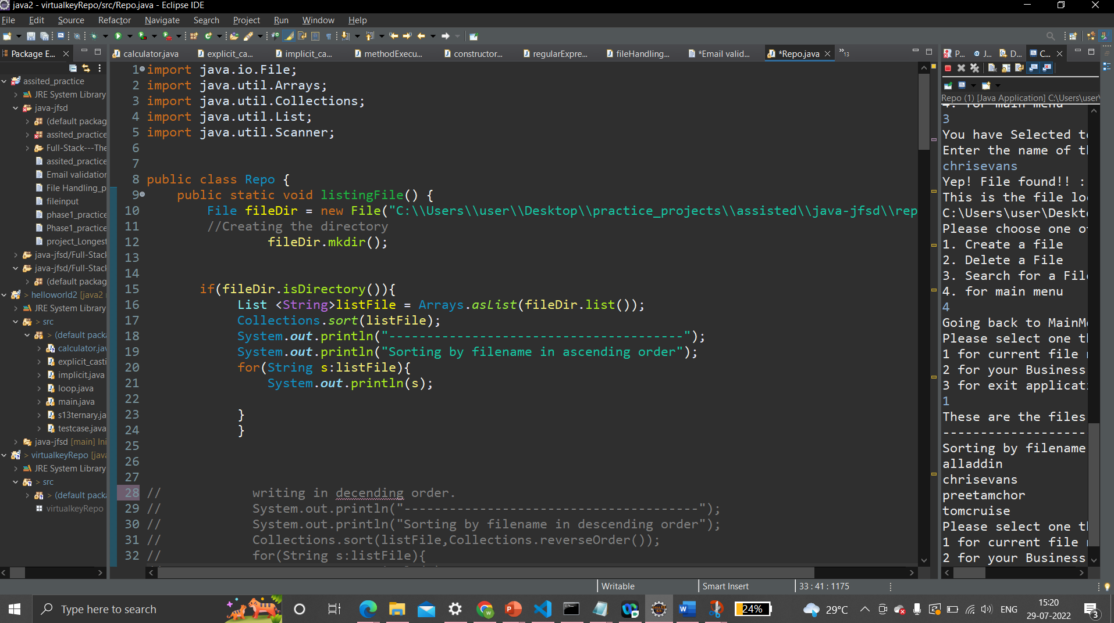

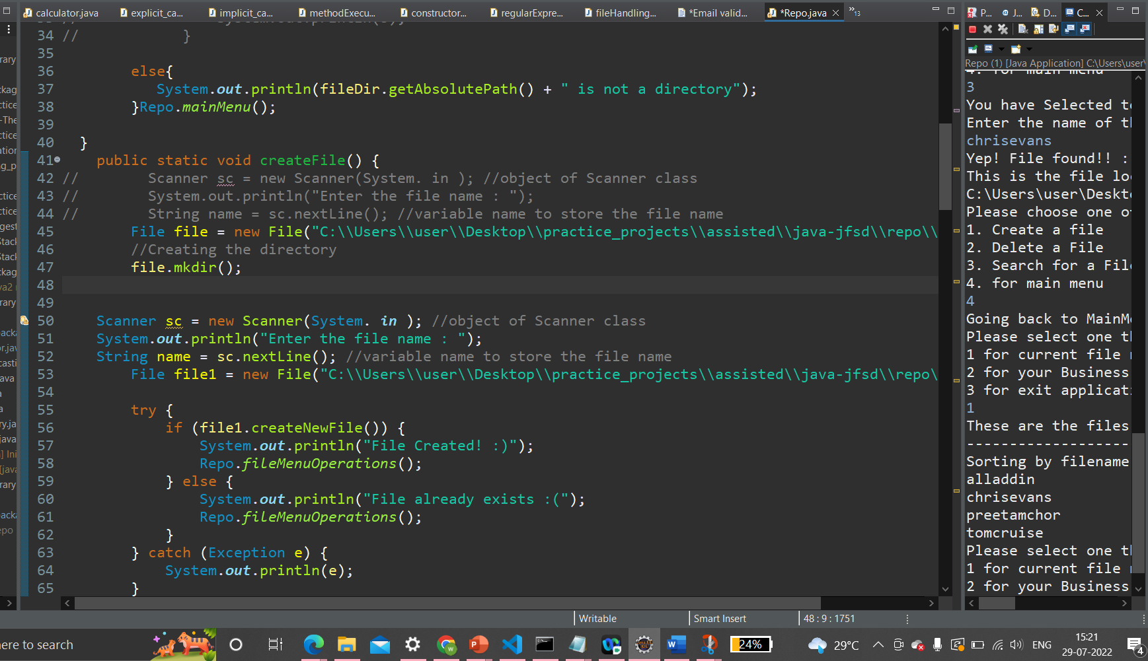

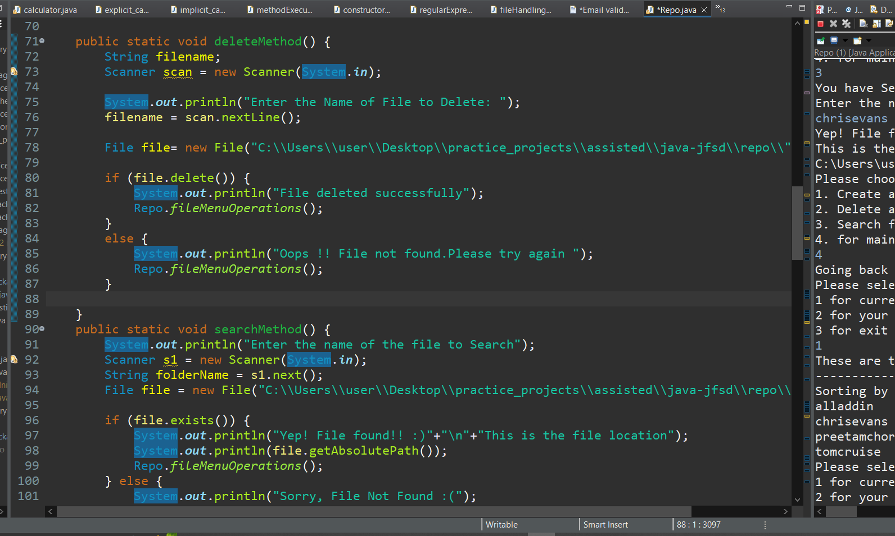

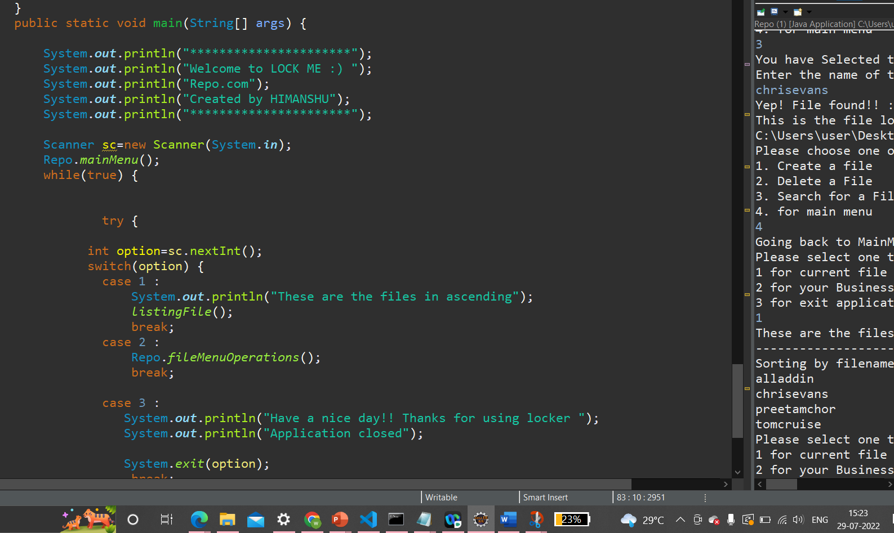

**Output:**

